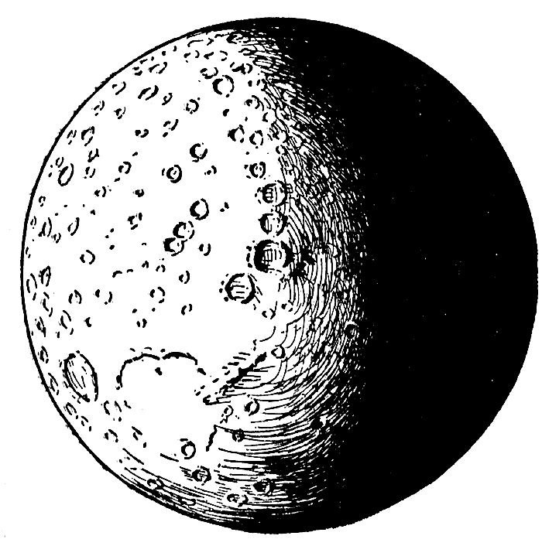

Critical Thinking- Lost on the Moon

1. Aims, Goals and Objectives
Our main goal in this activity is ________________________________

2. First Important Priority
What is your most important priority to reach your main goal?

3. Consider all Factors
What other things do you need to take into consideration to accomplish your main goal?

